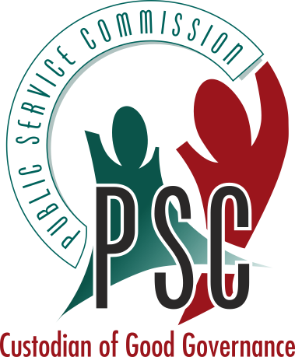
OFFICE OF THE PUBLIC SERVICE COMMISSION
REPUBLIC OF SOUTH AFRICA

Eastern Cape Regional Office: P.O. Box 2167, King William's Town, 5600, Tel: (043) 643 4704, Fax: (043) 642 1371
91 Alexandra Road, King William's Town, 5601
FAX COVER SHEET

TO:
DATE:
FROM:
SUBJECT:
NO. OF PAGES (including cover): | FAX:

Kind Regards
Name
Position
Tel:
Fax:
E-mail:

