FAX COVER SHEET

TO:
DATE:
FROM:
SUBJECT:
NO. OF PAGES (including cover): | FAX:

Kind Regards
Name
Position
Tel:
Fax:
E-mail:
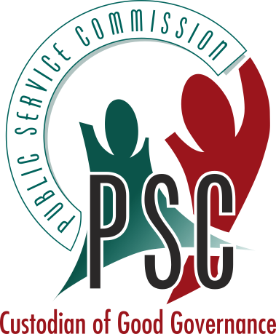
PUBLIC SERVICE COMMISSION
REPUBLIC OF SOUTH AFRICA

Free State Regional Office: Private Bag X20572, Bloemfontein, 9300, Tel: (051) 448 8696, Fax: (051) 448 4135
62 Fedsure Building, 3rd Floor, St. Andrew Street, Bloemfontein, 9301
