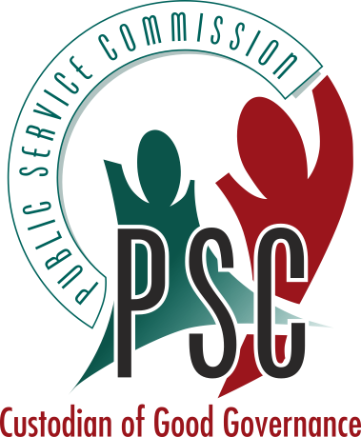
OFFICE OF THE PUBLIC SERVICE COMMISSION
REPUBLIC OF SOUTH AFRICA

KwaZulu-Natal Regional Office: Private Bag X9130, Pietermaritzburg, 3200, Tel: (033) 345 9998, Fax: (033) 345 8505
iDUBE Building, Ground Floor, 249 Burger Street, Pietermaritzburg, 3201

FAX COVER SHEET

TO:
DATE:
FROM:
SUBJECT:
NO. OF PAGES (including cover): | FAX:

Kind Regards
Name
Position
Tel:
Fax:
E-mail:
